**Postgres Installation and configuration guide**

|  |  |  |  |
| --- | --- | --- | --- |
| **Document Name** | **Version** | **Prepared by** | **Reviewed by** |
| Postgres Installation and configuration guide | v.01 | Tarunendra Tripathi | Sumit Malhotra |
|  |  |  |  |

Contents

Introduction 1

Get the rpm to install 1

Install the RPM files 1

Initialize Postgres Database 2

Verify the Postgres User 2

Create user and grants permission 3

Configure Postgres Database 4

Configure Postgres Port 4

Reference url 4

Create other user and permission commands 5

# Introduction

This document contains the installation and configuration of Ansible on RHEL environment.

# Get the rpm to install

Download below mentioned RPM files for installation.

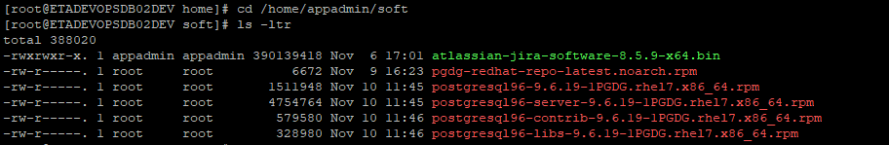

# Install the RPM files



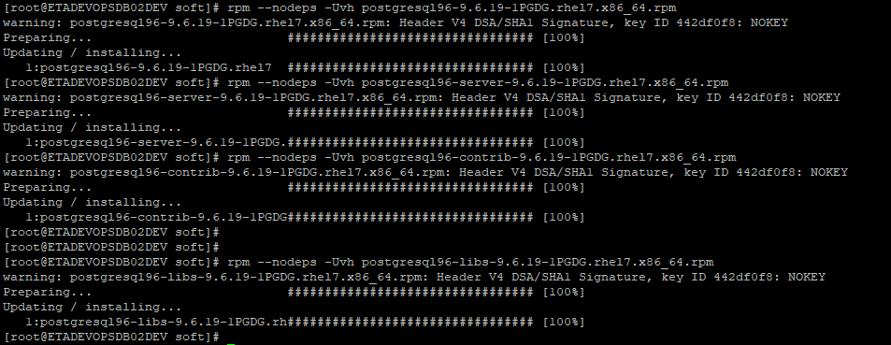

# Initialize Postgres Database

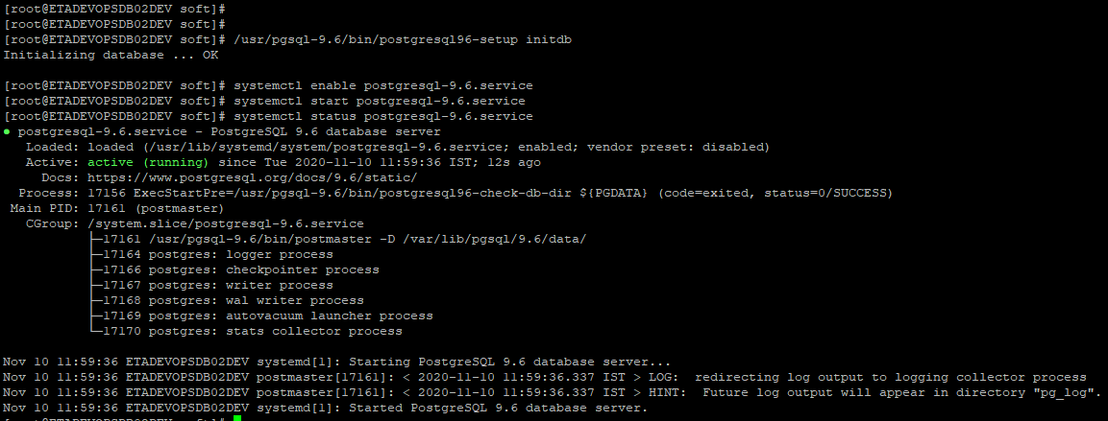

# Verify the Postgres User

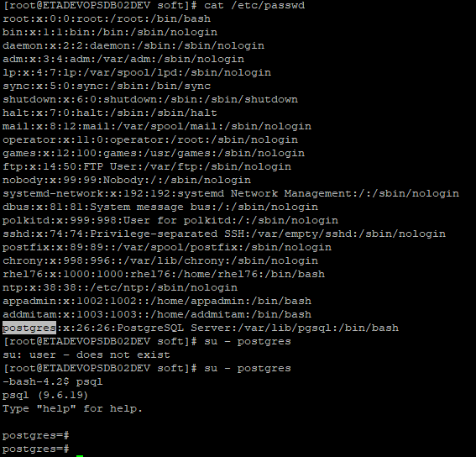

**psql** \conninfo --> to get the port information

# Create user and grants permission

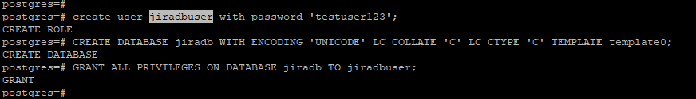

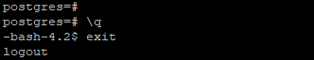

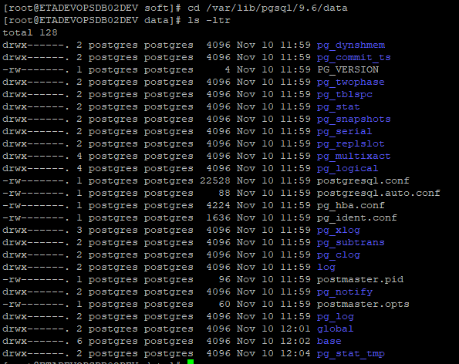

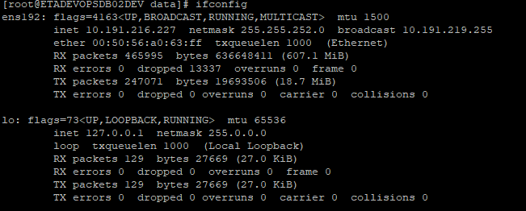

# Configure Postgres Database



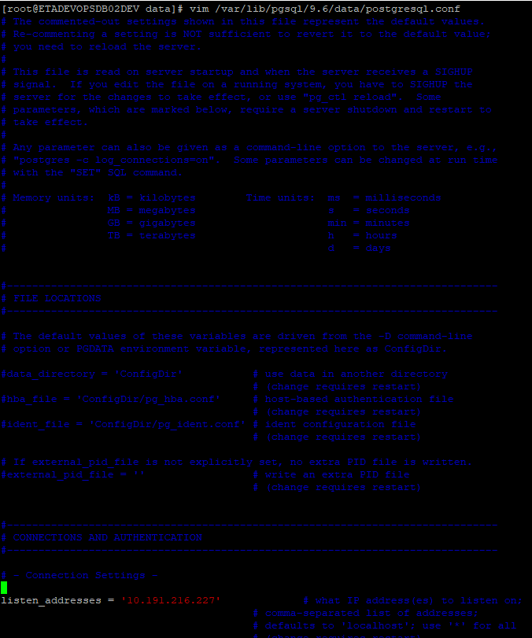

# Configure Postgres Port

## Reference url

<https://www.postgresql.org/docs/8.3/app-postgres.html>

su – postgres

netstat -lp --protocol=unix | grep postgres

export PGPORT=5454

psql

**psql** \conninfo



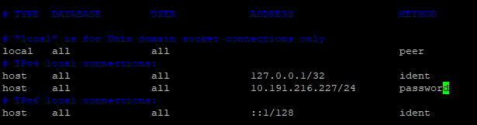





# Create other user and permission commands

-----------gitlab-------

CREATE USER gitlab WITH PASSWORD 'gitlab';

CREATE DATABASE gitlab WITH ENCODING 'UNICODE' LC_COLLATE 'C' LC_CTYPE 'C' TEMPLATE TEMPLATE0;

GRANT CONNECT ON DATABASE gitlab TO gitlab;

GRANT USAGE ON SCHEMA public TO gitlab;

GRANT SELECT, INSERT, UPDATE, DELETE ON ALL TABLES IN SCHEMA public TO gitlab;

GRANT ALL PRIVILEGES ON ALL TABLES IN SCHEMA public TO gitlab;

GRANT ALL PRIVILEGES ON ALL SEQUENCES IN SCHEMA public TO gitlab;

GRANT ALL PRIVILEGES ON DATABASE gitlab TO gitlab;

ALTER USER gitlab CREATEDB;

ALTER USER gitlab WITH SUPERUSER;

ALTER DEFAULT PRIVILEGES FOR USER gitlab IN SCHEMA public GRANT SELECT, INSERT, UPDATE, DELETE ON TABLES TO gitlab;

psql -U gitlab -d gitlab